UPduino LH154 Display Adapter   
Setup Instructions  
1/1/2018

**Introduction**

UPDuino is a small maker board with a Lattice Ultraplus mobile FPGA. The UPDuino LH154 Display Adapter Board provides the ability to attach a small 240x240 24-bit RGB display that has been used for many electronic devices including the iPod Nano (6th generation). The FPGA can be used as a small graphics processor to deliver interactive graphics, bitmaps, fonts/text on the display.

**High Level Block Diagram**

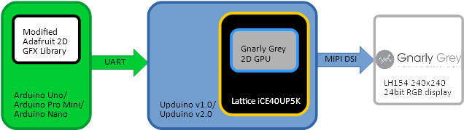

**Demo**

The provided firmware and software demo provides a 2D GPU design for the FPGA and a modified version of the Adafruit 2D GFX graphics library for Arduino. By attaching an Arduino and the display adapter to UPDuino, graphics commands can be delivered from the small Arduino ATMega328 8-bit microcontroller and accelerated in the FPGA. Additional, bitmaps and fonts can be loaded within the FPGA and loaded via commands in delivered with the Arduino microcontroller.

**Hardware Required**

* UPDuino v1.0 or v2.0 (and Adafruit FT232H USB to SPI programming module)
* Buck Boost Module for display backlight power
* Arduino Nano (possibly others)
* UPDuino LH154 Display Adapter Board
* IPod Nano 6th Generation Display (LH154Q01 240x240 24-bit RGB display)

**Hardware Setup Diagram (UPDuino v1.0 Setup) -**

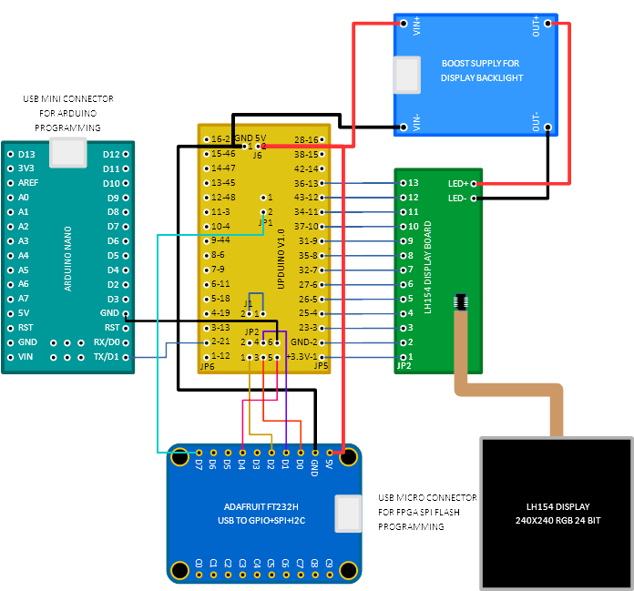

**Hardware Setup**

1. Solder male and female headers to the UPDuino board and connect together so that the 3.3V pins are connected together

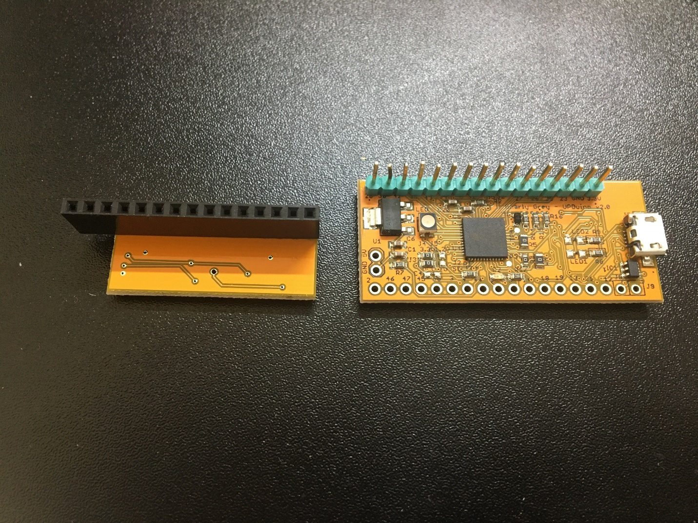

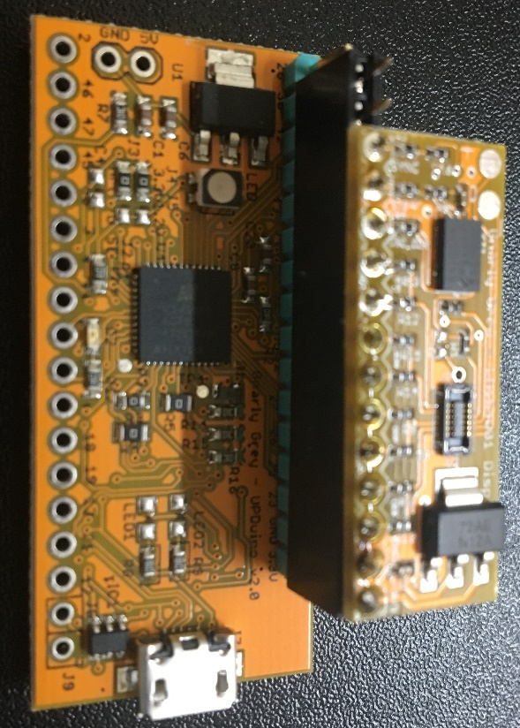

1. Add a 0.1” 1x2 header to the GND and 5V pins on the UPDuino board. Solder wires between the bottom of the GND and 5V pins on the UPDuino board and the input of the buck boost module. Solder wires to the output of the buck boost module and the large testpoints on the UPDuino LH154Q01 Display Adapter Board.

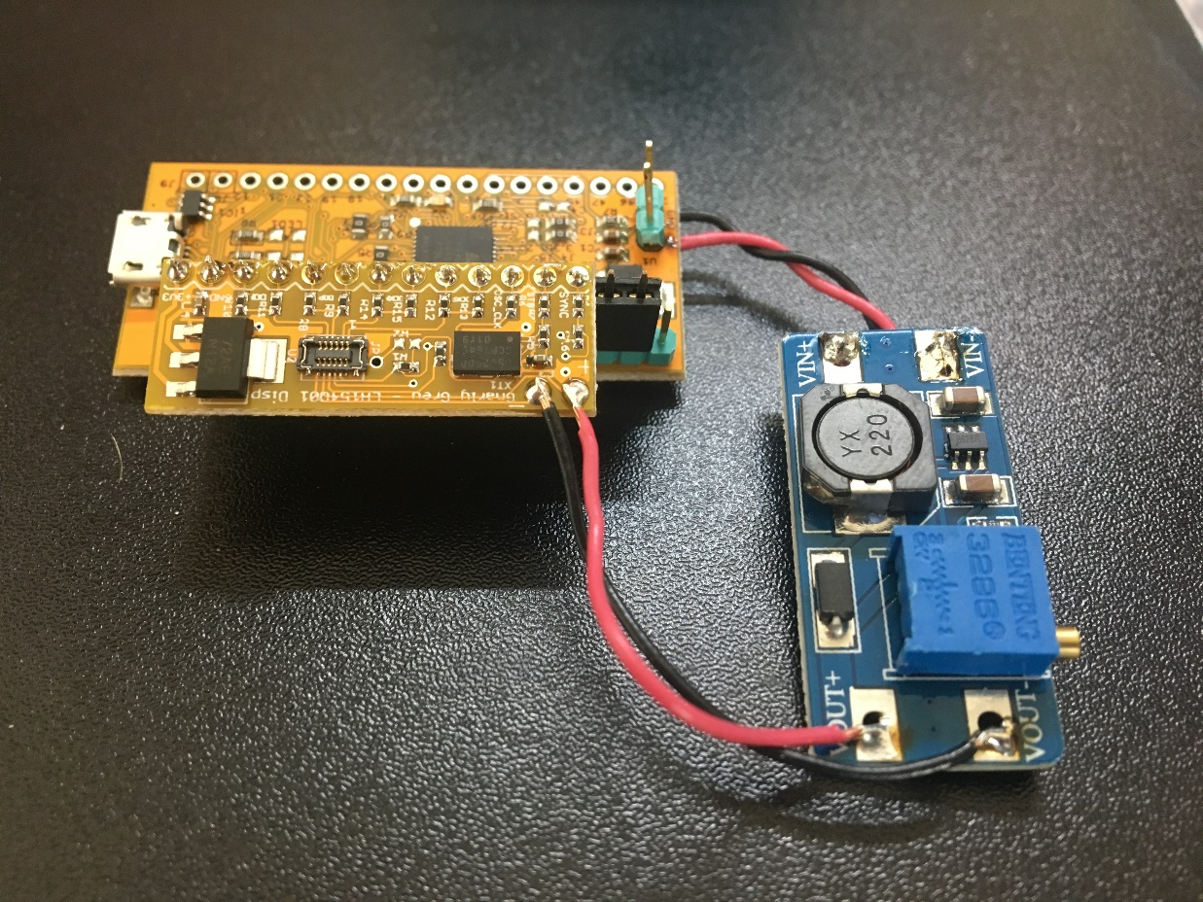

1. Remove the 0 ohm resistor on J4. Place a 0 ohm resistor or short J5. This is critical as it changes the voltage rail for the display from 3.3V to 1.2V. DO NOT POWER THE BOARD WITH THE DISPLAY CONNECTED UNTIL YOU MAKE THIS MODIFICATION. IF YOU DO YOU MAY BLOW UP YOUR DISPLAY!

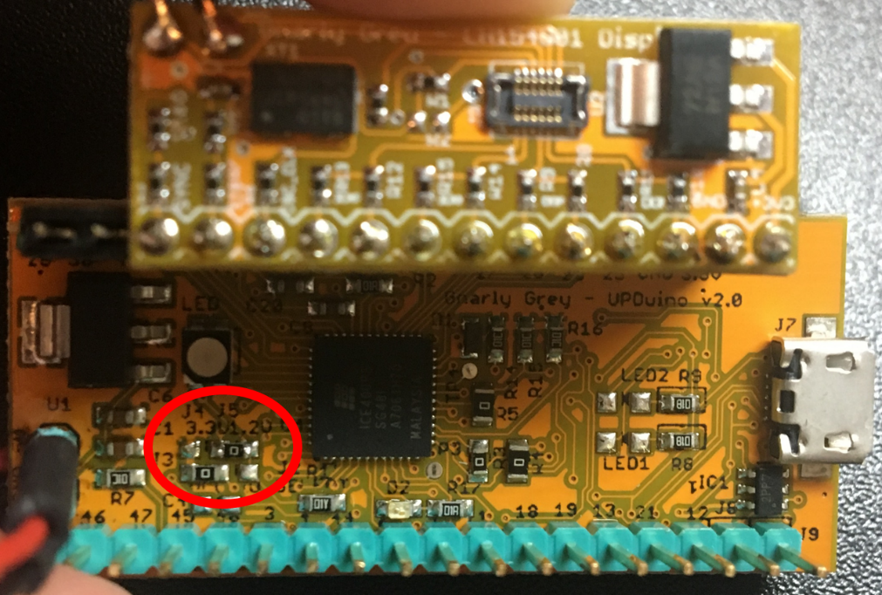

1. Add a .1” header between the UPDuino and Arduino Nano Boards. Connect them together such that pin 21 of the UPDUINO board connects with the TX1 pin of the Arduino Nano board. Add an additional header to the Arduino Nano board to connect GND and 5V to the UPDuino board via EZ-HOOK wires.

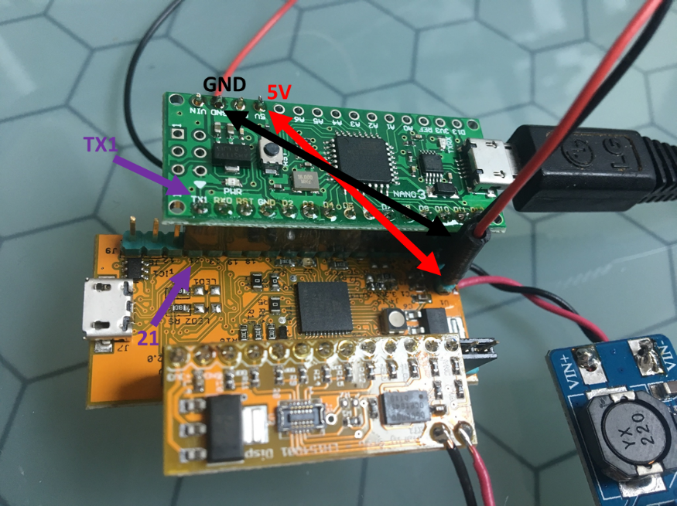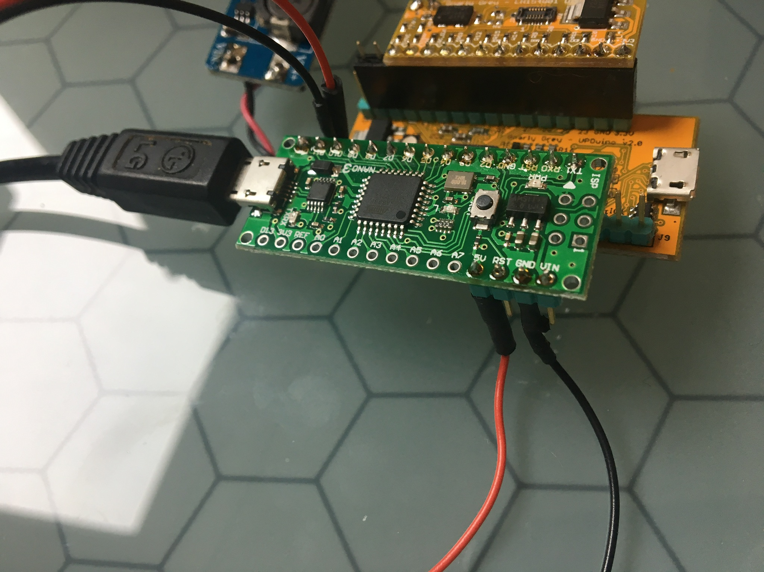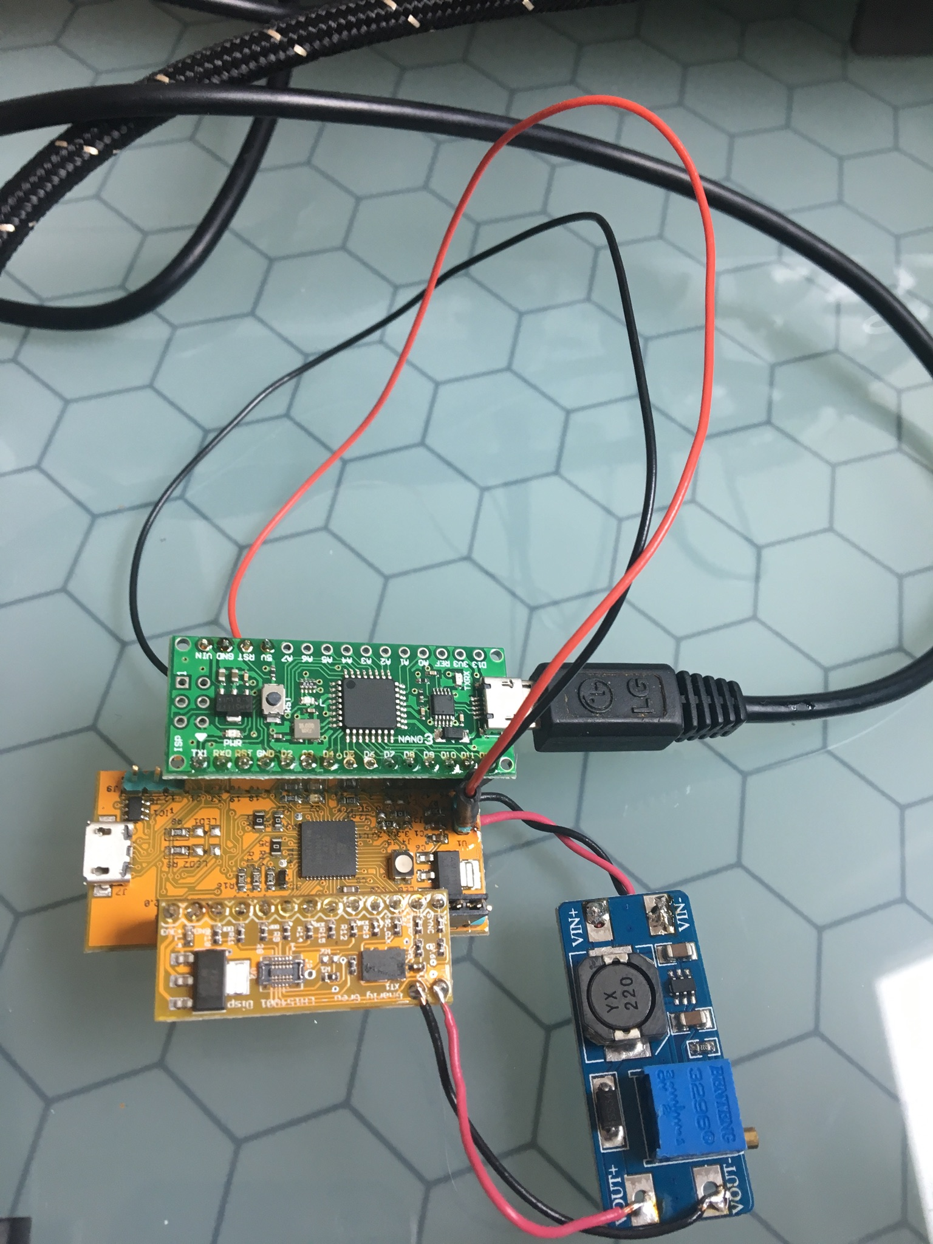

1. Connect a LH154Q01 display to the adapter board as shown. Display flex cable should connect going away from the LH154Q01 adapter board. Plug in USB micro cable to the UPDuino board. Display should be go white if no previous display bitstream was loaded.

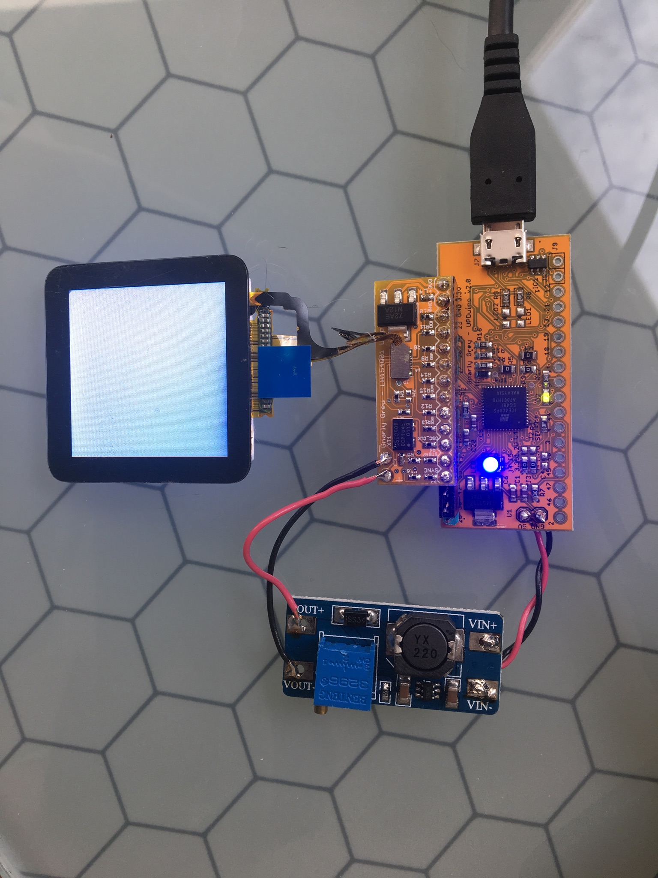

1. Load the FPGA SPI Flash with “GPU_bitmap.hex” by following the “FPGA Firmware Programming” Instructions in this document. After programming the display should have pseudo-ramdom pixel data on it. This is because the UPDuino is driving the display with image data from the frame buffer, but the frame buffer has not been loaded with any data (so it is just random data in the GPU frame buffer at this point).

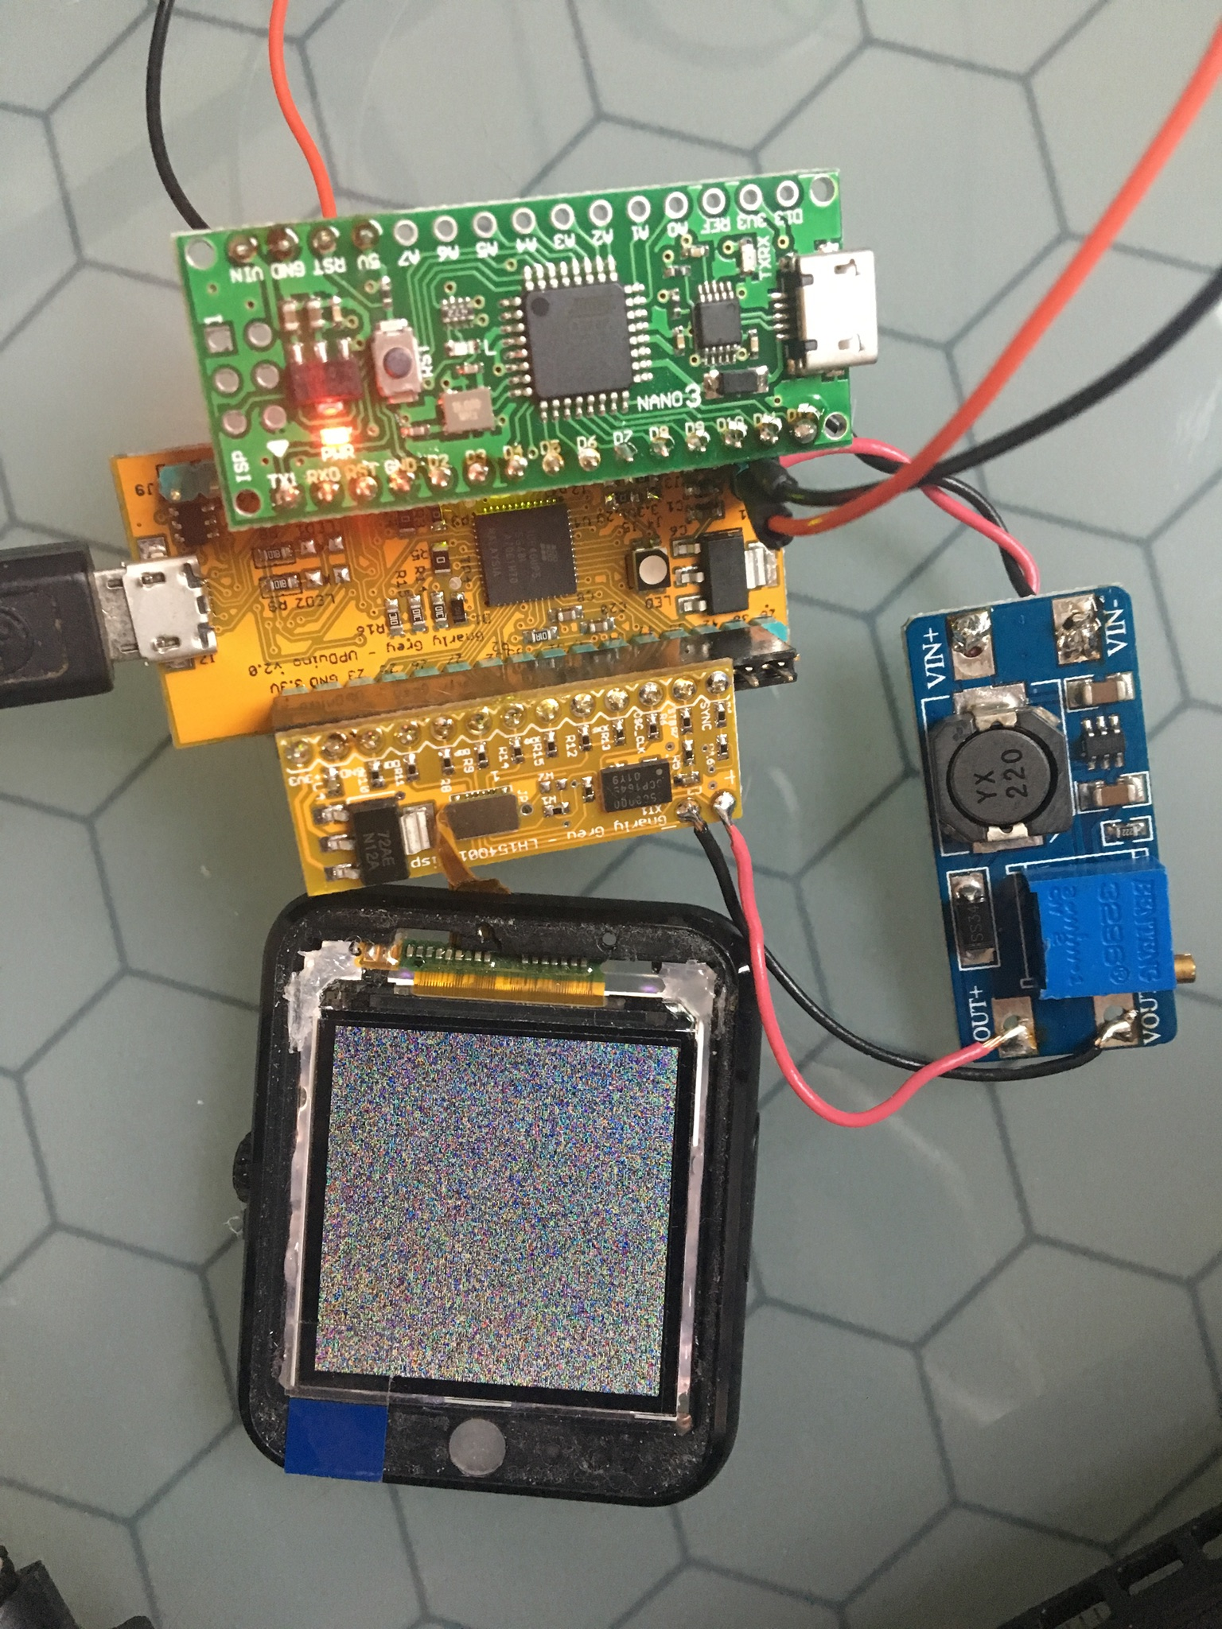

1. Now, remove the USB micro cable from the UPDuino and plug it into the Arduino Nano board. Open one of the Arduino example projects in the Arduino IDE using the “Arduino Software Programming” instructions in this document. Once the Arduino project is compiled and uploaded, cycle power to the boards by unplugging and replugging the USB micro cable in. The graphics example that was loaded should run.

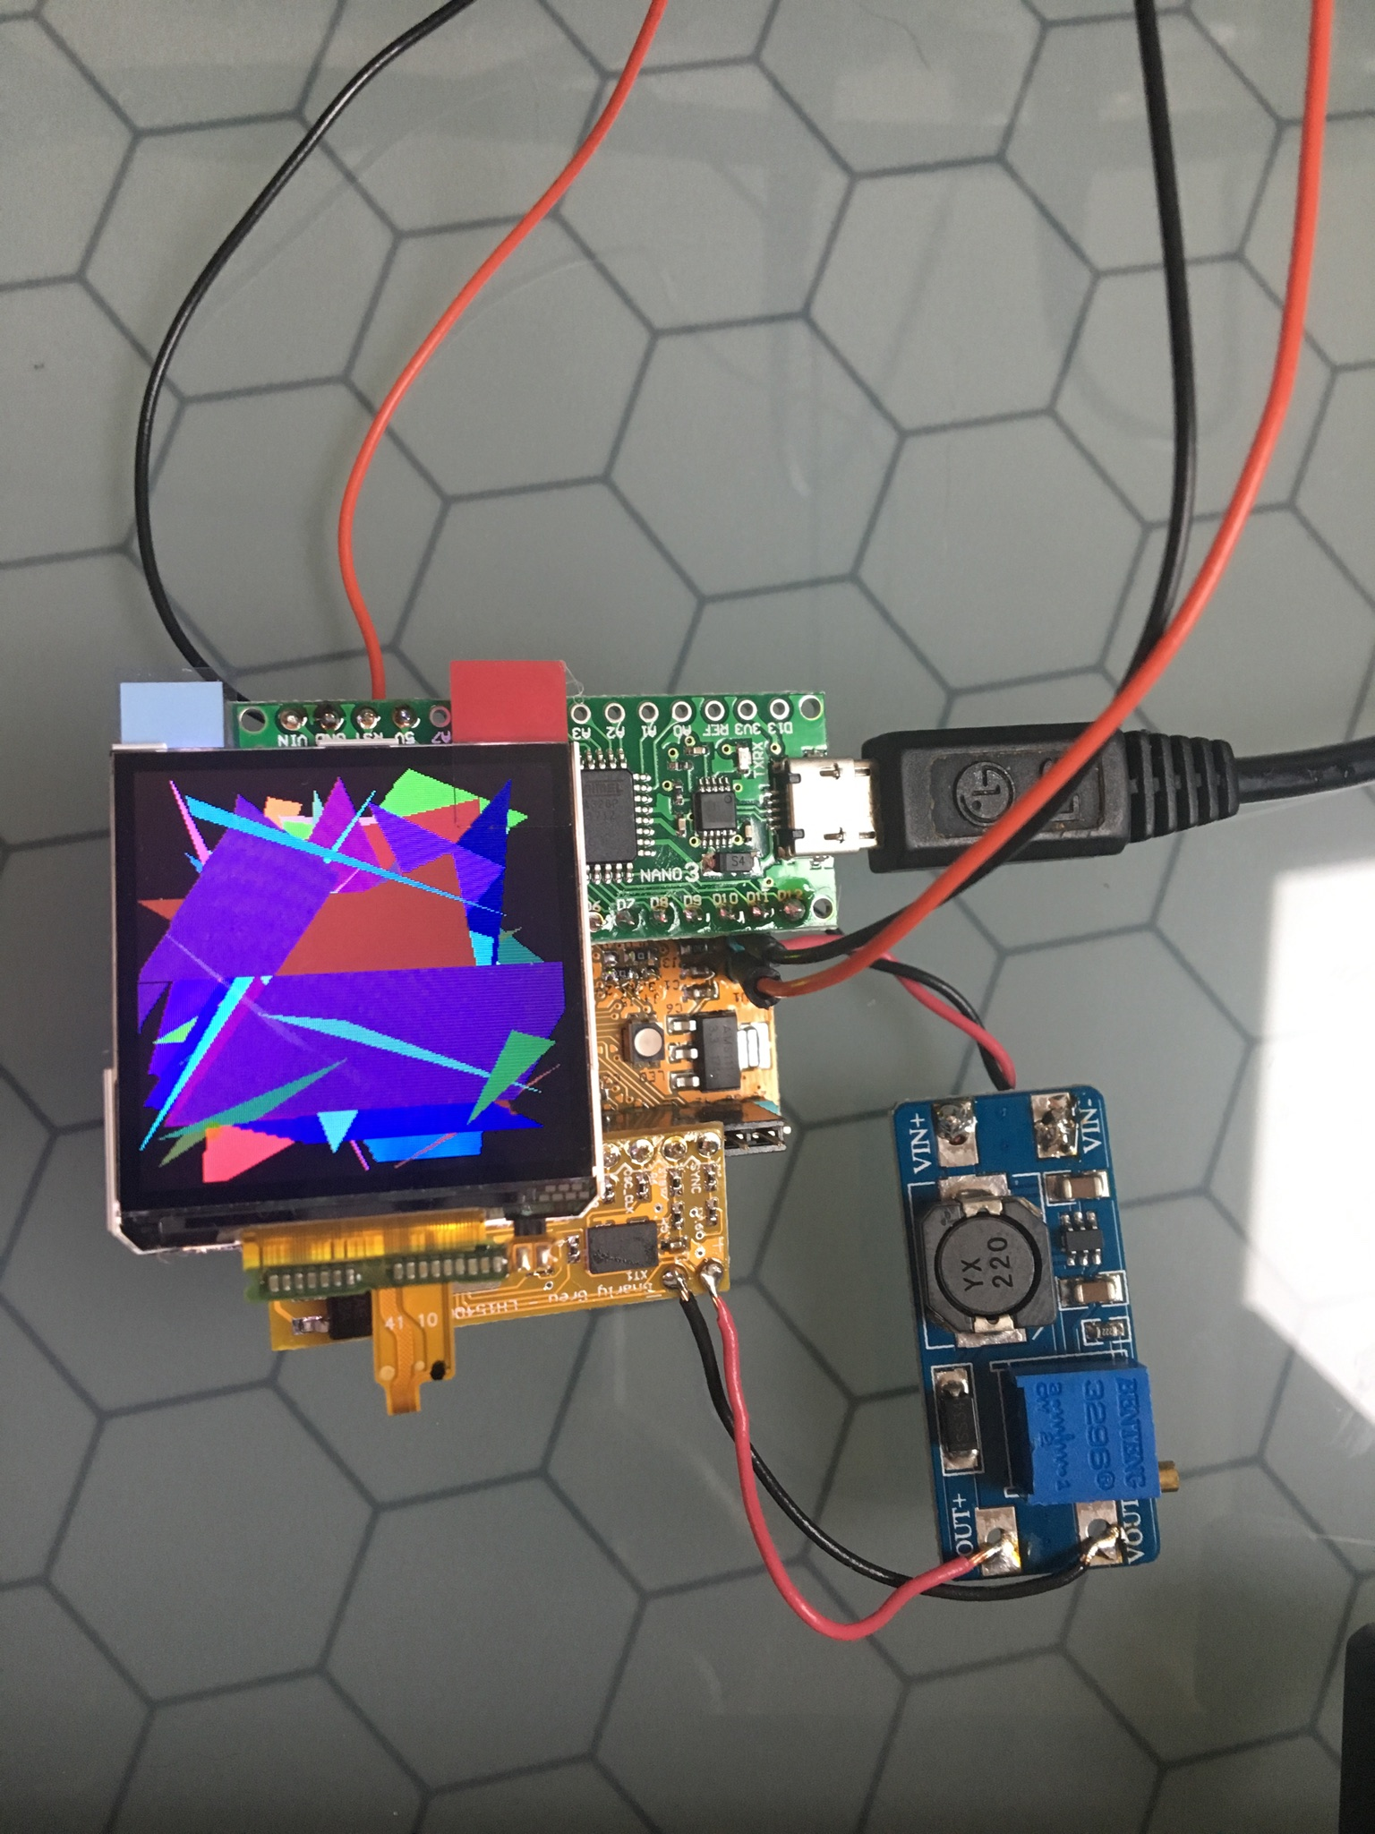

**FPGA Firmware Programming**

1. *Open Lattice Diamond Programmer*
2. *Click ‘Detect Cable’ then ‘OK’*
3. *After scanning select ‘Generic JTAG Device’ and ‘Select iCE40 UltraPlus’*
4. *Under ‘Device’ click iCE40UP3K and change it to iCE40UP5K*
5. *Under ‘Operation’ double click ‘Fast Program’ and change ‘Access Mode:’ to ‘SPI Flash Programming’*
6. *Select your *.hex programming file under ‘Programming file’.*
7. *Configure the following ‘SPI Flash Options’*
   1. *Numonyx*
   2. *SPI-N25Q032*
   3. *16-pin SOIC*
8. *Click ‘Load from File’ under ‘SPI Programming’ to get load size*
9. *Click ‘Design’→’Program’*

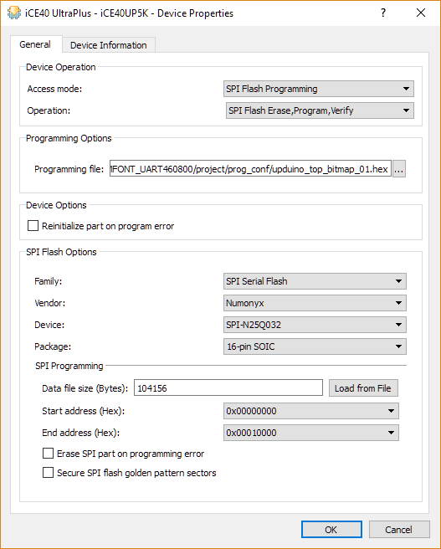

**Arduino Software Programming**

1. *Locate Arduino project folder which has sketch file (extension .ino) with name same as the project folder*
2. *Double click on .ino file to open Arduino IDE*
3. *From Tools→Boards, select “Arduino Nano”*
4. *From Tools→Port, select correct COM port*
5. *Press ‘Ctrl+U’ or Button with → to compile and upload program to Arduino*

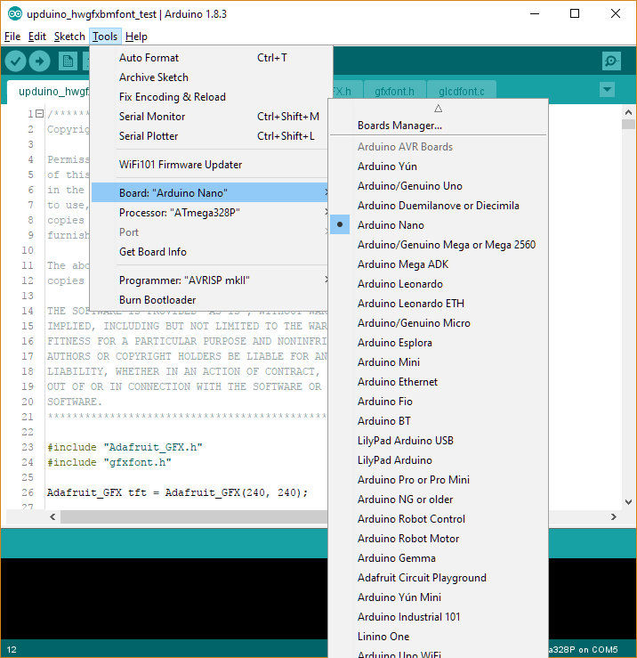

**Font loading**

Verilog File: ebr_font_mem.v

Fixed width font file: glcdfont.c (the default font for Adafruit GFX library)

1. *To covert font data from .c file to verilog defparam, use python script given below and edit <<source>> and <<destination>> file location:*

with open('<<source>>','r') as file_in:

with open('<<destination>>','w') as file_out:

char = file_in.read(1)

state = 0

line = 0

bm_no = 0

data_line_no = 0

data_start = 0

data_list = list()

while char != '':

if state == 0:

if char == '{':

state += 1

else:

state = 0

else:

if char == 'x':

data_list.append(file_in.read(2))

data_start = 1

elif char == '\n' and data_start == 1:

if line == 1:

line = 0

file_out.write('defparam bm')

file_out.write('%d' %bm_no)

file_out.write('.INIT_')

file_out.write('%X' %data_line_no)

file_out.write(' = 256\'h')

data_list.reverse()

for x in data_list:

file_out.write(x)

file_out.write(';\n')

del data_list[:]

data_line_no += 1

else:

line = 1

elif char == '}':

state = 0

data_start = 0

data_line_no = 0

bm_no += 1

file_out.write('\n\n');

char = file_in.read(1)

1. *Generated text file will have output as shown below:*

= 256'h5E1C1C577D571C183C7E3C181C3E7C3E1C3E6B4F6B3E3E5B4F5B3E0000000000;

= 256'h297929260E063A4830FFE7DBE7FF0018241800FFE7C3E7FF00183C18001C5E7F;

= 256'h5F14227F22147F3E1C1C08081C1C3E7F5A3CE73C5A3F25057F400705057F4026;

= 256'h7E201008047E040894A2FFA29460606060606A958966007F017F09065F5F005F;

= 256'h060E3E0E0630383E38300C1E0C1E0C101010101E08082A1C08081C2A08081020;

= 256'h49366264081323122A7F2A24147F147F14000700070000005F00000000000000;

= 256'h3070800008083E08082A1C7F1C2A001C2241000041221C000003070800502056;

= 256'h21464949497200407F42003E4549513E02040810200060600000080808080800;

= 256'h494946364949493607091121413149494A3C3945454527107F121418334D4941;

= 256'h0609590102081422410014141414144122140800000034400000001400001E29;

= 256'h097F414949497F3E4141417F224141413E364949497F7C1211127C4E595D413E;

= 256'h4040407F412214087F013F41402000417F41007F0808087F735141413E010909;

= 256'h26462919097F5E2151413E060909097F3E4141413E7F1008047F7F021C027F40;

= 256'h78040363140814633F4038403F1F2040201F3F4040403F03017F010332494949;

= 256'h404040404004020102047F4141410020100804024141417F00434D4959610304;

= 256'h080018545454387F284444382844444438384444287F40785454200008070300;

= 256'h407F4100004428107F003D40402000407D4400780404087F789CA4A41802097E;

= 256'h48080404087CFC1824241818242418FC3844444438780404087C780478047C00;

= 256'h90904C44281028443C4030403C1C2040201C7C2040403C24443F040424545454;

= 256'h3C2623263C0204020102000836410000007700000041360800444C5464447C90;

= 256'h542040785455214278545422417955552159555454387A2040403A1261A1A11E;

= 256'h7D450200417C4500005854545539595454543959555555391272521E0C407955;

= 256'h32497F090A7C547C545420004555547CF0282528F07D1211127D407C45010042;

= 256'h42423D7DA0A09D00782040423A7A2141413A3048484A323A4444443A32494949;

= 256'h03097E88C020F62909FF2B2FFC2F2B6643497E482424FF243C3D4040403D3D42;

= 256'h29267D31190D7D720A0A7A007A22404038324A484830417D4400004179545420;

= 256'h3428102FBAACC8102F3808080808080808083820404D48302629292926282F29;

= 256'h00FF55FF55FFAA55AA55AA550055005508142A142222142A140800007B0000FA;

= 256'hF7141400FC141414F010F01010FF00FF101000FF14141400FF10101000FF0000;

= 256'h00F0101010001F1414141F101F10101F10171414FC04F41414FF00FF0000FF00;

= 256'h000010FF101010101010101010FF00000010F0101010101F101010101F000000;

= 256'h00FF0000F404F414141710171414F404FC000017101F0000FF00FF000014FF00;

= 256'h00F010F0101014F41414141F101F10101417141414F700F714141414141414F7;

= 256'h10101014FF141414FF10FF1010F010F0000014FC000000141F0000001F101F00;

= 256'h0F0F0F0F0FFFFF0000000000FFFFFFF0F0F0F0F0FFFFFFFFFF10F0000000001F;

= 256'h7E40043C4444386341495563027E027E02060602027E344A4A4AFC4438444438;

= 256'h48784830304D4D4A304C7201724C1C2A492A1C99A5E7A59902027E0206201E20;

= 256'h4040444A514044445F44442A2A2A2A2A7E0101017E004949493E3D465A62BC30;

= 256'h180000060F090F063624361236086B6B08080000FF80E00301FF000040514A44;

= 256'h00000000003C3C3C3C0012171D19001E01011F000101FF403000101000000018;

1. *Copy first 16 lines to defparam list of font0 instance of SB_RAM512x8 in ebr_font_mem.v, next 16 lines to defparam list of font1 instance of SB_RAM512x8 and remaining 8 lines to defparam list of font2 instance of SB_RAM512x8 and fill remaining defparam list with =* 256'h0000000000000000000000000000000000000000000000000000000000000000;
2. Take reference from already created ebr_font_mem.v from <<Project>>/source/GPU folder in case of any doubt.

**Bitmap Loading**

Verilog File: ebr_bm_mem.v

Create C header file from monochrome bitmap using online tool: http://javl.github.io/image2cpp/

1. *Go to http://javl.github.io/image2cpp/ and upload bitmap file through '1. Select image'*
2. *In '2. Image Settings' set options as described below:*
   1. Canvas size/s: 64x64
   2. Background color: Black
   3. Invert image colors: Yes (tick the box)
   4. Brightness threshold: 200
   5. Scaling: original size
3. *In '4. Output' set options as described below:*
   1. Code output format: Arduino code
   2. Identifier: bitmap_01 (keep any name to differenciate multiple bitmap C header file)
   3. Draw mode: Horizontal
4. *Press 'Generate code' button to generate code and copy generated code in .h file (this will be source file to python script). Following is example of generated code:*

// '00_weather', 64x64px

const unsigned char bitmap_01 [] PROGMEM = {

0x00, 0x00, 0x00, 0x01, 0xff, 0x80, 0x00, 0x00, 0x00, 0x00, 0x00, 0x07, 0xff, 0xf0, 0x00, 0x00,

0x00, 0x00, 0x00, 0x1f, 0xe3, 0xfc, 0x00, 0x00, 0x00, 0x00, 0x00, 0x7e, 0x00, 0x3e, 0x00, 0x00,

0x00, 0x00, 0x00, 0xf8, 0x00, 0x0f, 0x00, 0x00, 0x00, 0x00, 0x01, 0xe0, 0x00, 0x07, 0x80, 0x00,

0x00, 0x00, 0x03, 0xc0, 0x00, 0x03, 0xc0, 0x00, 0x00, 0x00, 0x03, 0x80, 0x00, 0x01, 0xe0, 0x00,

0x00, 0x00, 0x07, 0x00, 0x00, 0x00, 0xe0, 0x00, 0x00, 0x00, 0x06, 0x00, 0x00, 0x00, 0x70, 0x00,

0x00, 0x00, 0x0e, 0x00, 0x00, 0x00, 0x30, 0x00, 0x00, 0x00, 0x0c, 0x00, 0x00, 0x00, 0x38, 0x00,

0x00, 0x00, 0xfc, 0x00, 0x00, 0x00, 0x38, 0x00, 0x00, 0x03, 0xfc, 0x00, 0x00, 0x00, 0x18, 0x00,

0x00, 0x0f, 0xf8, 0x00, 0x00, 0x00, 0x1c, 0x00, 0x00, 0x1e, 0x00, 0x00, 0x00, 0x00, 0x1f, 0x80,

0x00, 0x3c, 0x00, 0x00, 0x00, 0x00, 0x1f, 0xe0, 0x03, 0xf8, 0x00, 0x00, 0x00, 0x00, 0x1d, 0xf0,

0x07, 0xf0, 0x00, 0x00, 0x00, 0x00, 0x1c, 0x78, 0x1f, 0x00, 0x00, 0x00, 0x00, 0x00, 0x1c, 0x3c,

0x1c, 0x00, 0x00, 0x00, 0x00, 0x00, 0x1c, 0x1c, 0x38, 0x00, 0x00, 0x00, 0x00, 0x00, 0x18, 0x0e,

0x70, 0x00, 0x00, 0x00, 0x00, 0x00, 0x38, 0x06, 0x70, 0x00, 0x00, 0x00, 0x00, 0x00, 0x38, 0x07,

0xe0, 0x00, 0x00, 0x00, 0x00, 0x00, 0x30, 0x07, 0xe0, 0x00, 0x00, 0x00, 0x00, 0x00, 0x70, 0x07,

0xe0, 0x00, 0x00, 0x00, 0x00, 0x00, 0xe0, 0x03, 0xc0, 0x00, 0x00, 0x00, 0x00, 0x00, 0xe0, 0x03,

0xc0, 0x00, 0x00, 0x00, 0x00, 0x01, 0xc0, 0x07, 0xe0, 0x00, 0x00, 0x00, 0x00, 0x07, 0x80, 0x07,

0xe0, 0x00, 0x00, 0x00, 0x00, 0x0f, 0x00, 0x07, 0xe0, 0x00, 0x00, 0x00, 0x00, 0x3e, 0x00, 0x0e,

0x70, 0x00, 0x00, 0x00, 0x01, 0xfc, 0x00, 0x0e, 0x70, 0x00, 0x00, 0x00, 0x0f, 0xf0, 0x00, 0x1c,

0x38, 0x00, 0x00, 0x00, 0x0f, 0x80, 0x00, 0x38, 0x1e, 0x00, 0x00, 0x00, 0x00, 0x00, 0x00, 0xf8,

0x0f, 0x80, 0x00, 0x00, 0x00, 0x00, 0x07, 0xe0, 0x07, 0xff, 0xff, 0xff, 0xff, 0xff, 0xff, 0xc0,

0x01, 0xff, 0xff, 0xff, 0xff, 0xff, 0xff, 0x00, 0x00, 0x0f, 0xff, 0xff, 0xff, 0xff, 0xe0, 0x00,

0x00, 0x00, 0x18, 0x00, 0x00, 0x18, 0x00, 0x00, 0x00, 0x00, 0x18, 0x00, 0x00, 0x18, 0x00, 0x00,

0x00, 0x1f, 0xb8, 0x00, 0x00, 0x1d, 0xf8, 0x00, 0x00, 0x1f, 0xb8, 0x00, 0x00, 0x1d, 0xf8, 0x00,

0x00, 0x1f, 0x38, 0x00, 0x00, 0x1c, 0xf8, 0x00, 0x00, 0x00, 0x18, 0x00, 0x00, 0x18, 0x00, 0x00,

0x00, 0x00, 0x1c, 0x00, 0x00, 0x38, 0x00, 0x00, 0x00, 0x00, 0x1c, 0x00, 0x00, 0x38, 0x00, 0x00,

0x00, 0x00, 0x9c, 0x00, 0x00, 0x3b, 0x00, 0x00, 0x00, 0x03, 0xce, 0x00, 0x00, 0x73, 0xc0, 0x00,

0x00, 0x03, 0xcf, 0x00, 0x00, 0xf3, 0x80, 0x00, 0x00, 0x01, 0x07, 0x80, 0x01, 0xe0, 0x80, 0x00,

0x00, 0x00, 0x03, 0xc0, 0x03, 0xc0, 0x00, 0x00, 0x00, 0x00, 0x01, 0xf0, 0x0f, 0x80, 0x00, 0x00,

0x00, 0x00, 0x1c, 0xff, 0xff, 0x38, 0x00, 0x00, 0x00, 0x00, 0x3c, 0x3f, 0xfc, 0x3c, 0x00, 0x00,

0x00, 0x00, 0x78, 0x0f, 0xf0, 0x1e, 0x00, 0x00, 0x00, 0x00, 0x70, 0x40, 0x02, 0x0e, 0x00, 0x00,

0x00, 0x00, 0x20, 0xe0, 0x07, 0x04, 0x00, 0x00, 0x00, 0x00, 0x00, 0xe1, 0x87, 0x00, 0x00, 0x00,

0x00, 0x00, 0x00, 0xc1, 0x83, 0x00, 0x00, 0x00, 0x00, 0x00, 0x00, 0x01, 0x80, 0x00, 0x00, 0x00,

0x00, 0x00, 0x00, 0x01, 0x80, 0x00, 0x00, 0x00, 0x00, 0x00, 0x00, 0x01, 0x80, 0x00, 0x00, 0x00

};

1. *Maximum 24 different 64x64 monochrome bitmap can be used to store in Ultraplus EBR memory. Follow step 1 to 4 to generate C header for other bitmaps.*
2. *Once C header file is ready with necessary bitmap information, use following python scropt after editing <<source>> and <<destination>> location in it to generate EBR defparam data:*

with open('<<source>>','r') as file_in:

with open('<<destination>>','w') as file_out:

char = file_in.read(1)

state = 0

line = 0

bm_no = 0

data_line_no = 0

data_start = 0

data_list = list()

while char != '':

if state == 0:

if char == '{':

state += 1

else:

state = 0

else:

if char == 'x':

data_list.append(file_in.read(2))

data_start = 1

elif char == '\n' and data_start == 1:

if line == 1:

line = 0

file_out.write('defparam bm')

file_out.write('%d' %bm_no)

file_out.write('.INIT_')

file_out.write('%X' %data_line_no)

file_out.write(' = 256\'h')

data_list.reverse()

for x in data_list:

file_out.write(x)

file_out.write(';\n')

del data_list[:]

data_line_no += 1

else:

line = 1

elif char == '}':

state = 0

data_start = 0

data_line_no = 0

bm_no += 1

file_out.write('\n\n');

char = file_in.read(1)

1. *The script should generate output as example output shown below:*

defparam bm0.INIT_0 = 256'h00003e007e0000000000fcf71f0000000000f0ff07000000000080ff01000000;

defparam bm0.INIT_1 = 256'h00e001008007000000c00300c003000000800700e001000000001f00f8000000;

defparam bm0.INIT_2 = 256'h00380000001e000000780000000e000000700000000e000000f0000000070000;

defparam bm0.INIT_3 = 256'h801f000000001f00001c000000f80f00001c000000fc03000038000000fc0000;

defparam bm0.INIT_4 = 256'h3c1c00000000801f781c00000000f007f01d00000000f803e01f000000007c00;

defparam bm0.INIT_5 = 256'h07380000000000700f380000000000700e1c0000000000381c1c00000000003e;

defparam bm0.INIT_6 = 256'h07e00100000000e007f00000000000e007700000000000e007780000000000e0;

defparam bm0.INIT_7 = 256'h0e003e00000000e007000f00000000e007800700000000e007c00300000000e0;

defparam bm0.INIT_8 = 256'hf80000000000001e3c00c00f0000003c1c00f00f000000780e00fc0300000070;

defparam bm0.INIT_9 = 256'h00f8ffffffff1f0080ffffffffffff01c0ffffffffffff07f00700000000c00f;

defparam bm0.INIT_A = 256'h00f81d0000b81f0000f81d0000b81f00000018000018000000003800001c0000;

defparam bm0.INIT_B = 256'h00003800001c000000003800001c000000001c000038000000f81d0000b81f00;

defparam bm0.INIT_C = 256'h0080e0018007010000c0f30000cf030000c0730000ce030000003b0000dc0000;

defparam bm0.INIT_D = 256'h00003cfc3f3c0000000038ffff1c00000000900ff00900000000c003c0030000;

defparam bm0.INIT_E = 256'h00000087e100000000000687e160000000000e066070000000001ef00f780000;

defparam bm0.INIT_F = 256'h00000080010000000000008001000000000000800100000000000083c1000000;

1. *In ebr_bm_mem.v file edit/add EBR memory instances as necessary and use defparam data generated by python script.*